The area of visual field loss is shaded

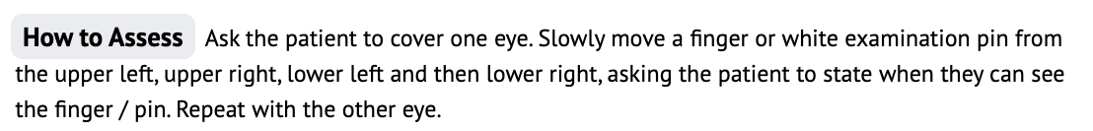

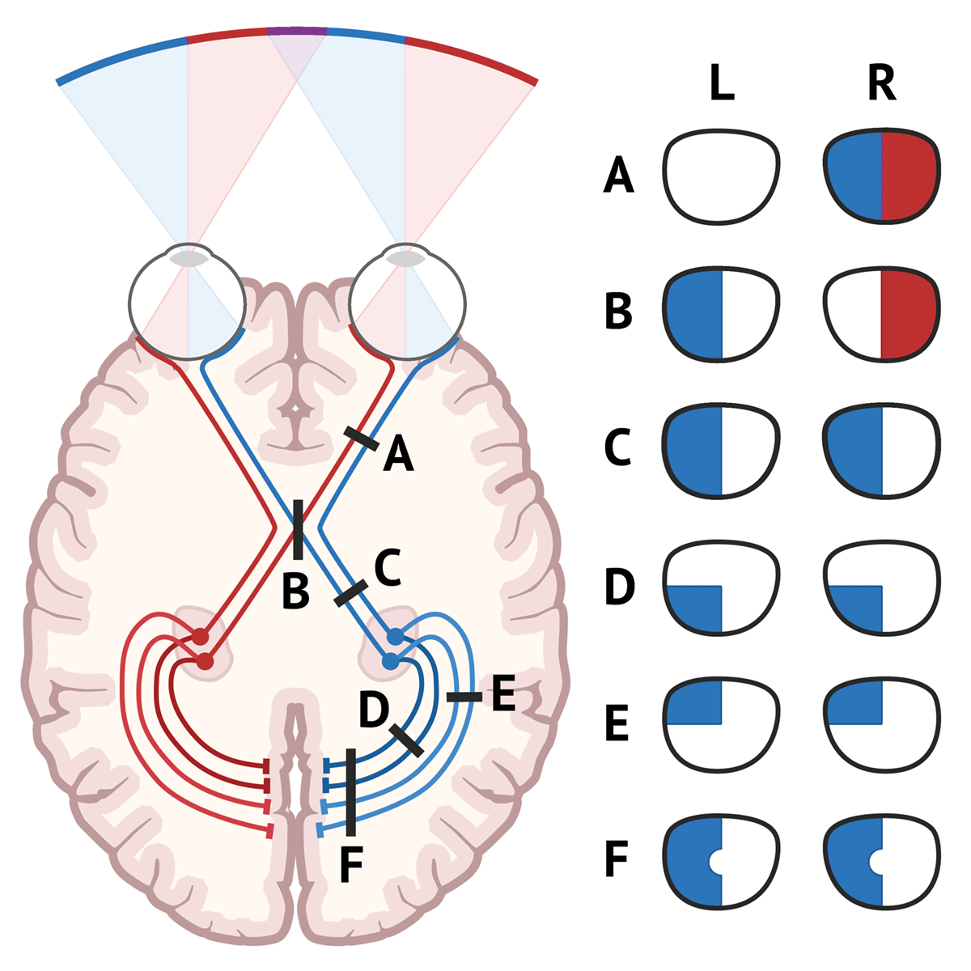

<https://medschool.co/images/detail/opticpathway.gif>

**Dear students,**

**this diagram demonstrates the visual field loss nicely with colour coding.**

**Remember**

1. **the visual field is the environment that you can see.**
2. **eyes are tested separately.**